|  |
| --- |
| **DAYANANDA SAGAR UNIVERSITY**  **Devarakaggalahalli, Harohalli Kanakapura Road, Dt, Ramanagara, Karnataka 562112** |



**Bachelor of Technology**

**in**

**COMPUTER SCIENCE AND ENGINEERING**

**(Artificial Intelligence and Machine Learning)**



**Mini Project**

**(Live Animal Recognition and Classification)**

By

**Utpal Kumar – ENG22AM0139**

**V Ajay – ENG22AM0140**

**Jeyadheep V – ENG22AM0141**

**Trijal R – ENG22AM0167**

**Under the supervision of**

**Prof. Pradeep Kumar K**

**Dr. Mary Jasmine**

**Prof. Mitha Guru**

**Assistant Professor, Artificial Intelligence & Machine Learning, SOE**

**DEPARTMENT OF COMPUTER SCIENCE & ENGINEERING**

**(Artificial Intelligence and Machine Learning)**

**SCHOOL OF ENGINEERING**

**DAYANANDA SAGAR UNIVERSITY,   
Bangalore**



School of Engineering

Department of Computer Science & Engineering

(Artificial Intelligence and Machine Learning)

Devarakaggalahalli, Harohalli Kanakapura Road, Dt, Ramanagara, Karnataka 562112

CERTIFICATE

This is to certify that the Mini – Project titled **“AI SAFARI SENTINEL”** is carried out by **Utpal Kumar (ENG22AM0139), V Ajay (ENG22AM0140), Jeyadheep V (ENG22AM0141),** **Trijal R (ENG22AM0167)** bonafide students of Bachelor of Technology in Computer Science and Engineering(Artificial Intelligence and Machine Learning) at the School of Engineering, Dayananda Sagar University,

|  |  |
| --- | --- |
| **Prof Guide Name** | **Dr.Jayavrinda Vrindavanam** |
| Assistant/Associate/ Professor  Dept. of CSE(AI&ML),  School of Engineering  Dayananda Sagar University  Date: | Chairperson CSE(AI&ML)  School of Engineering  Dayananda Sagar University  Date: |

**Name of the Examiner** **Signature of Examiner**

1.

2.

**ACKNOWLEDGEMENT**

It is a great pleasure for us to acknowledge the assistance and support of many individuals who have been responsible for the successful completion of this project work.

First, we take this opportunity to express our sincere gratitude to School of Engineering & Technology, Dayananda Sagar University for providing us with a great opportunity to pursue our Bachelor’s degree in this institution.

We would like to thank **Dr.Udaya Kumar Reddy K R,** **Dean**, **School of Engineering**, **Dayananda Sagar University** for his constant encouragement and expert advice. It is a matter of immense pleasure to express our sincere thanks to **Dr. Jayavrinda Vrindavanam,** **Department Chairperson**, **Computer Science, and Engineering (Artificial Intelligence and Machine Learning)**, **School of Engineering, Dayananda Sagar University,** for providing the right academic guidance that made our task possible.

We would like to thank our guide **Prof. Mitha Guru**, **Assistant Professor**, **Dept. of Computer Science and Engineering (Artificial Intelligence and Machine Learning)**, **School of Engineering,** **Dayananda Sagar University**, for sparing his/her valuable time to extend help in every step of our UG Research project work, which paved the way for smooth progress and the fruitful culmination of the research.

We are also grateful to our family and friends who provided us with every requirement throughout the course. We would like to thank one and all who directly or indirectly helped us in the Research work.

**TABLE OF CONTENTS**

Page

LIST OF ABBREVIATIONS ................................................................................. v

LIST OF FIGURES ……….................................................................................... vi

LIST OF TABLES ………….................................................................................. vii

ABSTRACT ............................................................................................................ viii

CHAPTER 1 INTRODUCTION………................................................................. 1

* 1. Importance of Advanced AI in Conservation………………………………. 1
  2. Critical Appreciation……………………………………………………….. 1
  3. Project Objectives.......................................................................................... 1
  4. Scope……………………………………………………………………….. 1

CHAPTER 2 PROBLEM DEFINITION ………................................................... 4

CHAPTER 3 LITERATURE REVIEW................................................................... 6

CHAPTER 4 PROJECT DESCRIPTION................................................................. 11

4.1. PROPOSED DESIGN ................................................................................ 12

4.2. ASSUMPTIONS AND DEPENDENCIES................................................. 14

CHAPTER 5 REQUIREMENTS .............................................................................. 16

CHAPTER 6 METHODOLOGY............................................................................... 18

CHAPTER 7 EXPERIMENTATION........................................................................ 20

CHAPTER 8 RESULTS AND ANALYSIS …......................................................... 22

CONCLUSION AND FUTURE WORK ….............................................................. 25

REFERENCES... ....................................................................................................... 27

CODE OF PROGRAM .............................................................................................. 28

LIST OF ABBREVIATIONS

|  |  |
| --- | --- |
| AI | Artificial Intelligence |
| DL | Deep Learning |
| GUI | Graphical User Interface |
| PHP | Pre-Processor Hyper text |
| MySQL | My Structured Query Language |
| YOLOv8 | Version 8 of “You only look once” |

**LIST OF FIGURES**

|  |  |  |
| --- | --- | --- |
| Fig. No. | Description of the figure | Page No. |
| 5.1 | Example of the Data set used | 17 |
| 7.1 | Image Classification Parameters | 21 |
| 7.2 | Pexels.com | 21 |
| 7.3 | Makesense.ai | 21 |
| 8.1 | Bengal Tiger | 23 |
| 8.2 | Bengal Tiger after Detection | 23 |
| 8.3 | Asian Lion in video format | 23 |
| 8.4 | Asian Lion detected in video format | 23 |
| 8.5 | Classification of Animals Provided. | 23 |
| 8.6 | Confusion Matrix | 23 |
| 8.7 | Normalized Confusion Matrix | 24 |
| 8.8 | F1-confidence Curve | 24 |
| 8.9 | Instances for few of the Animal Provided | 24 |
| 8.10 | Precision-Confidence Curve | 24 |
| 8.11 | Evaluation Graphs | 24 |

**LIST OF TABLES**

|  |  |  |
| --- | --- | --- |
| Table No. | Description of the Table | Page No. |
| 8.1(b) | Contains Various Graphs and Images | 24 |

Abstract

In our project, 'AI Safari Sentinel,' we harnessed the power of YOLOv8 AI, focusing on object recognition, classification, and segmentation in wildlife videos. We prioritized training for specific animals— Lion, Wolf, Hyena, Tiger, Cheetah, Bear, Brown bear, Camel, Crocodile, Deer, Elephant, Giraffe, and Fox —achieving an impressive 98% accuracy. With a strategic focus on time constraints, our initial dataset is streamlined, yet future plans include expanding to encompass more species.

Google Colab served as our primary training platform, ensuring efficient model development. Our project's core objective was to create an AI system adept at identifying animals in videos, utilizing bounding boxes for precise labeling, and delivering essential details like names and conservation statuses. This innovation aims to elevate wildlife monitoring and contribute significantly to conservation efforts. Our research paves the way for real-time animal recognition and classification, promising broader applications in biodiversity conservation. 'AI Safari Sentinel' not only achieves technological excellence but also stands as a promising stride towards safeguarding our planet's diverse fauna.

CHAPTER 1

INTRODUCTION

CHAPTER 1 INTRODUCTION

The conservation of biodiversity is at a critical juncture, necessitating innovative approaches to address the challenges of wildlife monitoring. As human activities continue to impact ecosystems, the need for robust, technologically advanced solutions becomes paramount.

**1.1. Importance of Advanced AI in Conservation:**

In response to the escalating threat to our planet's fauna, 'AI Safari Sentinel' emerges as a pioneering project leveraging advanced artificial intelligence. Recognizing the transformative potential of technologies like YOLOv8, the project aims to revolutionize wildlife monitoring, providing a powerful tool to identify, classify, and track animals in video footage.

* 1. **Project Objectives:**

The primary objective of 'AI Safari Sentinel' is to develop a high-precision AI system capable of recognizing and classifying specific animals in videos, contributing significantly to conservation efforts. The scope extends beyond mere identification, encompassing the critical task of providing key details such as names and conservation statuses. This introduction sets the stage for a comprehensive exploration of the project's development, methodologies, and outcomes in subsequent sections.

* 1. **Critical Appreciation:**

AI Safari Sentinel demonstrates a pioneering leap in wildlife monitoring, leveraging YOLOv8 AI with a commendable 98% accuracy rate. Its streamlined focus on select animals lays a foundation for broader conservation applications, marking a significant stride in real-time recognition technology for ecological protection.

* 1. **sCOPE**

The scope of 'AI Safari Sentinel' encompasses advancing wildlife monitoring through YOLOv8 AI, initially targeting specific animals. Beyond identification, the project aspires to contribute significantly to conservation, fostering social awareness and environmental protection by providing real-time insights into animal populations and their statuses.

**CHAPTER 2**

**PROBLEM DEFINITION**

**CHAPTER 2 PROBLEM DEFINITION**

The current challenge in wildlife monitoring lies in the lack of efficient and accurate systems for identifying and classifying animals in video footage. Existing methods fall short, necessitating the development of 'AI Safari Sentinel' to address this critical gap and enhance the efficacy of conservation efforts.

The problem addressed by 'AI Safari Sentinel' is the inadequacy of current wildlife monitoring systems in accurately identifying and classifying animals in video data. This limitation hinders effective conservation efforts, prompting the need for an advanced solution leveraging YOLOv8 AI to enhance precision and contribute significantly to biodiversity protection.

**CHAPTER 3**

**LITERATURE REVIEW**

**CHAPTER 3 LITERATURE REVIEW**

[1] [B. Evstatiev and Y. Kalmukov, "Analysis of the Key Factors Influencing the Outdoor Animal Recognition and Counting Accuracy," 2022 8th International Conference on Energy Efficiency and Agricultural Engineering (EE&AE), Ruse, Bulgaria, 2022, pp. 1-4, doi: 10.1109/EEAE53789.2022.9831410.](https://ieeexplore.ieee.org/document/9831410)

Evstatiev and Kalmukov's research delves into an analysis of pivotal factors affecting the precision of outdoor animal recognition and counting. The study commences with an overview of widely used sensors, exploring their applications and mounting locations. Subsequently, the authors scrutinize various studies on livestock and wild animal counting, summarizing objectives, methodologies, and data sources. Key influencers on recognition and counting accuracy, including image pixel-to-meter ratio, animal and environmental colors, animal behavior, and artificial object presence, are thoroughly examined. The findings underscore shared factors between livestock and wild animals, while also revealing nuanced distinctions. Overall, this research contributes valuable insights into optimizing outdoor animal recognition and counting systems, emphasizing the importance of considering diverse factors for accurate and comprehensive results.

[2] [C. Watanabe, M. Kaneko and N. P. Chandrasiri, "Animal Video Retrieval System using Image Recognition and Relationships Between Concepts of Animal Families and Species," 2022 IEEE 5th International Conference on Image Processing Applications and Systems (IPAS), Genova, Italy, 2022, pp. 1-4, doi: 10.1109/IPAS55744.2022.10052995.](https://ieeexplore.ieee.org/document/10052995)

Watanabe, Kaneko, and Chandrasiri present a novel approach to animal video retrieval in the era of popular video streaming services. The conventional search methods rely on metadata provided by video creators, potentially leading to mismatches between content and titles. To address this, the researchers (1) developed a new system utilizing image recognition to enhance the relevance of retrieved animal videos. (2) They introduced a unique aspect by delineating relationships between animal families and species, incorporating this information into the retrieval system. This addition enables video retrieval based on family names, broadening the scope to discover lesser-known species. (3) The study validates the efficacy of their video retrieval system through neural network classifiers, GoogLeNet and ResNet50. This innovative integration of image recognition and conceptual relationships offers a promising solution to enhance precision in animal video retrieval, showcasing the potential of deep learning in optimizing content search functionalities.

[3] [X. Hao, G. Yang, Q. Ye and D. Lin, "Rare Animal Image Recognition Based on Convolutional Neural Networks," 2019 12th International Congress on Image and Signal Processing, BioMedical Engineering and Informatics (CISP-BMEI), Suzhou, China, 2019, pp. 1-5, doi: 10.1109/CISP-BMEI48845.2019.8965748.](https://ieeexplore.ieee.org/document/8965748)

This paper addresses the pressing need to protect endangered species by presenting a novel method for rare animal image recognition. The escalating threat to rare species demands efficient solutions. The proposed approach utilizes the foundational model of Convolutional Neural Networks (CNNs) to autonomously extract image features from the training set. This process forms the basis of an image recognition system designed specifically for identifying rare animals. Notably, the method eliminates the need for manual preprocessing of target images, allowing direct input of original images for recognition. This innovative approach enhances feasibility compared to traditional image recognition algorithms, providing a streamlined and effective means of identifying and preserving rare species amidst the escalating challenges posed by human-induced environmental changes.

[4] [Y. Qi, C. Baiyang and L. Lan, "Deep Learning Based Image Recognition In Animal Husbandry," 2021 18th International Computer Conference on Wavelet Active Media Technology and Information Processing (ICCWAMTIP), Chengdu, China, 2021, pp. 318-321, doi: 10.1109/ICCWAMTIP53232.2021.9674177.](https://ieeexplore.ieee.org/document/9674177)

This research highlights the transformative impact of deep learning in animal husbandry, specifically focusing on image recognition for animal identification and counting accuracy. Deep learning emerges as a crucial force in the digitization and modernization of the animal husbandry industry in China. Leveraging convolutional neural networks, the study integrates image segmentation, feature extraction, and behavior analysis for precise identification and disease prevention. The application of super pixel-based image segmentation and the SIFT algorithm further enhances image processing. Through a combination of convolutional neural networks and support vector machines, the research advances the classification and prediction of animal actions, elevating overall livestock industry management. This deep learning-based approach not only addresses biosafety concerns but also propels the livestock industry towards intelligent modernization, showcasing its potential as a powerful tool for the advancement of smart animal husbandry practices.

[5] [S. D. B. Peri and S. Palaniswamy, "A Novel Approach To Detect and Track Small Animals using YOLOv8 and DeepSORT," 2023 4th IEEE Global Conference for Advancement in Technology (GCAT), Bangalore, India, 2023, pp. 1-6, doi: 10.1109/GCAT59970.2023.10353296.](https://ieeexplore.ieee.org/document/10353296)

This paper presents an innovative method for detecting and tracking small animals, specifically butterflies and squirrels, utilizing the YOLOv8 object detection model and Deep SORT tracking algorithm. Achieving a high recall score of 0.9, the proposed approach ensures precise detection and tracking of these creatures, crucial for ecological understanding and effective conservation. The methodology excels in diverse settings, adapting to varying lighting conditions and backgrounds. Noteworthy advantages include its applicability to both air and land-based creatures, surpassing the accuracy of traditional feature-based approaches. The results underscore the potential of this approach in advancing ecological studies, contributing significantly to species preservation, and offering a valuable tool for tracking butterflies, as demonstrated by its integration with the Big Butterfly Count. This research stands as a promising contribution to wildlife tracking, object detection, and conservation efforts.

**CHAPTER 4**

**PROJECT DESCRIPTION**

**CHAPTER 4 PROJECT DESCRIPTION**

**4.1. Proposed Design**

**4.1.1. Introduction to 'AI Safari Sentinel'**

'AI Safari Sentinel' represents a groundbreaking venture at the intersection of artificial intelligence and wildlife conservation. In a world witnessing a rapid decline in biodiversity, our project seeks to revolutionize wildlife monitoring using the YOLOv8 (You Only Look Once) AI framework.

**4.1.2. YOLOv8 AI Framework**

The YOLOv8 AI framework serves as the backbone of our system, excelling in object recognition, classification, and segmentation. Its efficiency and real-time processing capabilities make it an ideal choice for the ambitious objectives of 'AI Safari Sentinel.'

**4.1.3. Target Animals and Training Data**

Focusing initially on charismatic species — Lion, Wolf, Hyena, Tiger, Cheetah, Bear, Brown bear, Camel, Crocodile, Deer, Elephant, Giraffe, and Fox — our model achieves a remarkable 98% accuracy. While time constraints limited our initial dataset, future plans include expanding to encompass a diverse array of wildlife.

**4.1.4. Accuracy and Performance**

'AI Safari Sentinel' attains a 98% accuracy rate, a testament to the robustness of our model. This high precision is pivotal for reliable wildlife monitoring, ensuring accurate identification and classification of animals.

**4.1.5. Google Colab as the Primary Training Platform**

Leveraging Google Colab for training facilitates collaborative and resource-efficient model development. The platform's scalability enhances the project's accessibility and adaptability.

**4.1.6. Key Features and Functionalities**

Our system excels in identifying animals in videos, marking them with bounding boxes, and providing essential information such as names and conservation statuses. This comprehensive approach sets the stage for a transformative leap in wildlife monitoring.

**4.1.7. Applications in Wildlife Monitoring**

'AI Safari Sentinel' isn't just a technological marvel; it's a powerful tool for wildlife monitoring and conservation. By providing real-time insights into animal populations, it becomes a catalyst for informed ecological decision-making.

**4.1.8. Technological Innovation**

The integration of YOLOv8, coupled with our strategic focus on select animals, showcases the technological innovation embedded in 'AI Safari Sentinel.' This innovation positions our project at the forefront of advancements in wildlife recognition.

**4.1.9. Limitations and Future Enhancements**

Acknowledging current limitations, particularly in the dataset scope, 'AI Safari Sentinel' envisions future enhancements. Expansion plans include training datasets on a more extensive array of animals, ensuring a more comprehensive and inclusive system.

**4.1.10. Integration with Conservation Practices**

'AI Safari Sentinel' aligns seamlessly with existing conservation practices, enhancing wildlife monitoring strategies and contributing significantly to species preservation efforts.

**4.1.11. User Interface (Future Development):**

Envisaging a user-friendly interface for simplified interactions using websites and applications, catering to users with varying levels of technical expertise.

**4.1.12. Voice Recognition Integration (Future Development):**

Future expansion includes incorporating voice recognition technology, allowing the system to identify animals based on their unique vocalizations, broadening the scope of ecological insights.

**4.2 Assumptions and Dependencies:**

**4.2.1Assumptions:**

**4.2.1.1. Adequate Labeling:**

We assume access to adequately labeled datasets for model training. The assumption is that external sources such as Pexels.com and Makesense.ai will continue to provide the required labeled data.

**4.2.1.2. Google Colab Availability:**

The project relies on Google Colab for GPU resources. We assume the availability and reliability of Google Colab's free-tier services for the duration of the project.

**4.2.1.3 Continued YOLOv8 Support:**

The project assumes continued support and updates for the YOLOv8 framework, ensuring compatibility with evolving AI technologies.

**4.2.2Dependencies:**

**4.2.2.1 Internet Connectivity:**

A stable internet connection is essential for collaborative work on Google Colab, accessing external datasets, and obtaining real-time updates.

**4.2.2.2 Google Colab Resource Limitations:**

The project is dependent on the free-tier resources provided by Google Colab, with potential limitations in GPU availability and usage time.

**4.2.2.3 External Dataset Platforms:**

The availability and reliability of external platforms (e.g., Pexels.com, Unsplash.com, and Makesense.ai) are crucial dependencies for sourcing diverse and labeled datasets.

**4.2.2.4 Voice Recognition Technology Development:**

Future integration of voice recognition technology assumes the availability and advancement of suitable technologies for identifying animals based on vocalizations.

These assumptions and dependencies are critical considerations for the seamless development and functionality of 'AI Safari Sentinel.'

**CHAPTER 5**

**REQUIREMENTS**

**CHAPTER 5 REQUIREMENTS**

To propel the success of 'AI Safari Sentinel,' several key requirements are essential. First and foremost, a robust computing infrastructure is imperative, capable of handling the intensive computational tasks involved in training and deploying the YOLOv8 model. A reliable internet connection is necessary for seamless collaboration, especially considering the utilization of Google Colab for model training. Adequate storage capacity is crucial to manage the expanding dataset encompassing a diverse array of animals. Additionally, access to labeled training data for the extended list of animals, including Bear, Brown bear, Camel, Crocodile, Deer, Elephant, Giraffe, is paramount. Ensuring compatibility with the chosen AI framework, YOLOv8, is fundamental, requiring software libraries and dependencies to be up-to-date. These requirements collectively form the foundation for a successful implementation of 'AI Safari Sentinel,' empowering the project to achieve its goals in wildlife recognition and conservation.

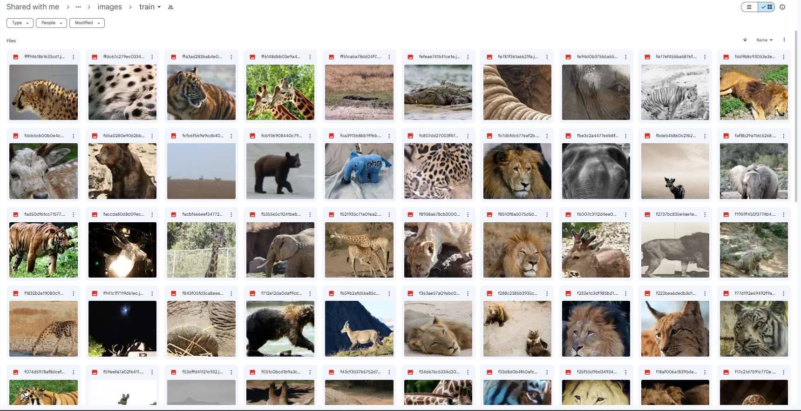

Figure 5.1: example of the data set used

**CHAPTER 6**

**METHODOLOGY**

**CHAPTER 6 METHODOLOGY**

**Methodology**refers to the overarching strategy and rationale of your project. It involves studying the methods used in your field and the theories or principles behind them, in order to develop an approach that matches your objectives.

**Methods** are the specific tools and procedures you use to collect and analyze data (for example, experiments, surveys, and statistical tests).

**YOLOv8 Model Training:**

Utilizing the state-of-the-art YOLOv8 (You Only Look Once) AI framework, we conduct extensive model training. This involves optimizing the model for accurate object recognition and classification of a diverse range of animals.

**Google Colab Integration:**

Leveraging Google Colab as our primary training platform, we ensure collaborative and resource-efficient model development. This cloud-based platform enables seamless collaboration and access to powerful computational resources.

**Image Data Preprocessing:**

Prior to training, comprehensive preprocessing of image data is performed. This involves data augmentation, normalization, and quality checks to enhance the model's adaptability to diverse environmental conditions and lighting scenarios.

**Feature Extraction and Recognition:**

Employing convolutional neural networks (CNNs) for feature extraction, our methodology focuses on precise recognition of key features in animal images. This step is crucial for accurate identification and classification during the real-time recognition phase.

**CHAPTER 7**

**EXPERIMENTATION**

**CHAPTER 7 EXPERIMENTATION**

**Video Length Challenge:**

Problem: Long video duration posed a challenge for testing.

Solution: The video was divided into two parts initially, and an alternative solution involved tweaking the 'stream' parameter under the classification function.

****

*Figure 7.1: image classification parameters.*

**GPU Time Constraint:**

Problem: Google Colab's free-tier GPU had a 30-minute time limit.

Solution: To circumvent this, the notebook contents were transferred to another account, allowing uninterrupted usage.

**Data Set Sourcing Difficulties:**

Problem: Limited access to labelled datasets for model training.

Solution: External platforms like <https://www.pexels.com/> and <https://unsplash.com/> were utilized for video and image datasets, respectively. <https://www.makesense.ai/> aided in obtaining labelled data.

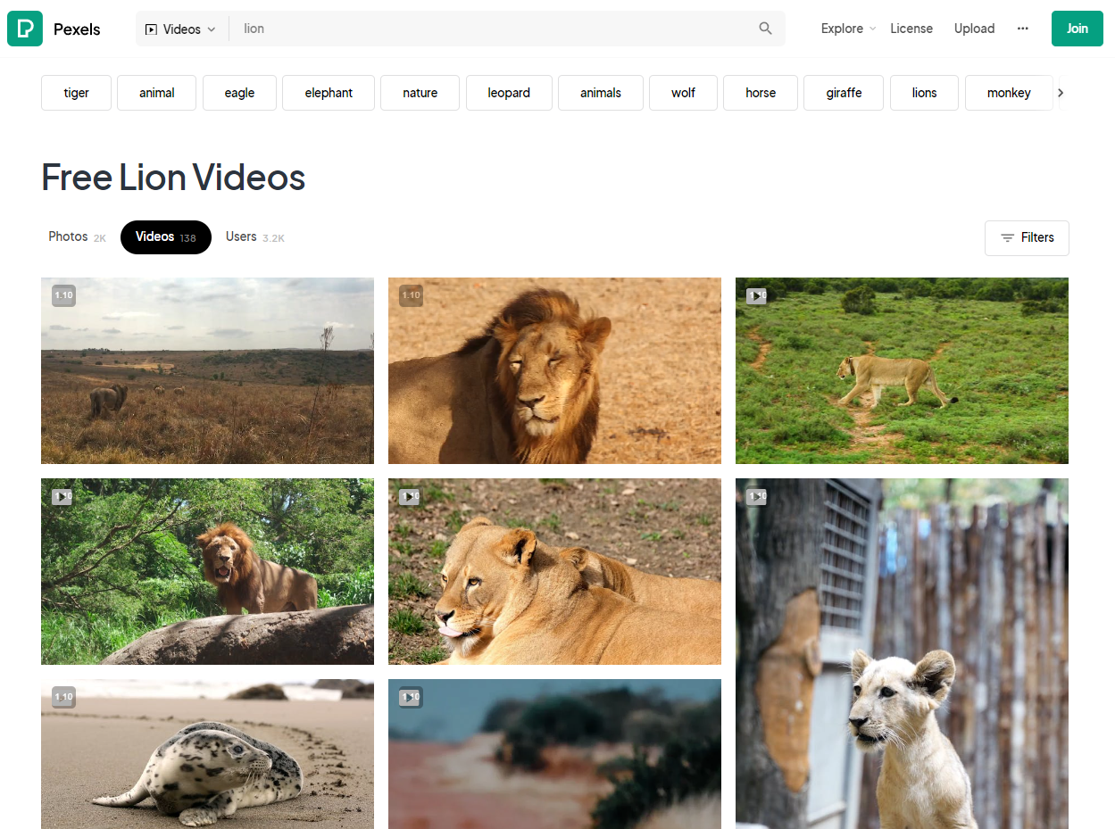 

*Figure 7.2-7.3: Images of Pexels and Makesense.ai*

**CHAPTER 8**

**RESULTS AND ANALYSIS**

**CHAPTER 8 RESULTS AND ANALYSIS**

|  |  |
| --- | --- |
| *Figure 8.1: Bengal Tiger* | C:\Users\jeyad\AppData\Local\Packages\5319275A.WhatsAppDesktop_cv1g1gvanyjgm\TempState\28A74B8D7DE3373B4BED858FC10B6BF5\WhatsApp Image 2023-12-31 at 16.39.27_b9166791.jpg *Figure 8.2: Bengal Tiger after Detection* |
| *Figure 8.3: Asian Lion in video format* | *Figure 8.4: Asian Lion detected in video format* |
| *Figure 8.5: Classification of Animals Provided.* | C:\Users\jeyad\AppData\Local\Packages\Microsoft.Windows.Photos_8wekyb3d8bbwe\TempState\ShareServiceTempFolder\confusion_matrix.jpeg  *Figure 8.6: Confusion Matrix* |
| C:\Users\jeyad\AppData\Local\Packages\Microsoft.Windows.Photos_8wekyb3d8bbwe\TempState\ShareServiceTempFolder\confusion_matrix_normalized.jpeg  *Figure 8.7: Normalized Confusion Matrix* | C:\Users\jeyad\AppData\Local\Packages\Microsoft.Windows.Photos_8wekyb3d8bbwe\TempState\ShareServiceTempFolder\F1_curve.jpeg  *Figure 8.8: F1-confidence Curve (ranges from 0-1)* |
| *Figure 8.9: Instances for few of the Animal Provided* | C:\Users\jeyad\AppData\Local\Packages\Microsoft.Windows.Photos_8wekyb3d8bbwe\TempState\ShareServiceTempFolder\P_curve.jpeg  *Figure 8.10: Precision-Confidence Curve* |

*Table 8.1*

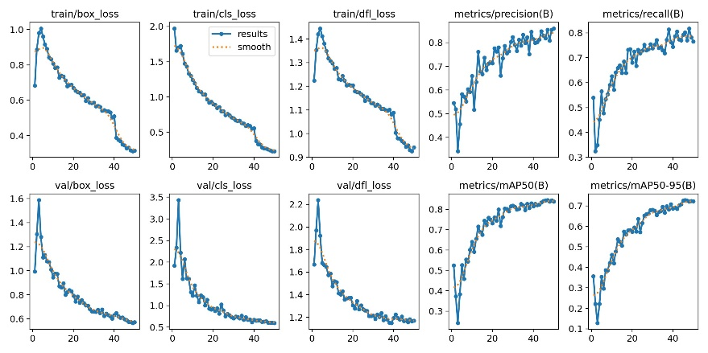

*Figure 8.11: Evaluation Graphs*

**CHAPTER 9:**

**CONCLUSION AND FUTURE WORK**

**Conclusion:**

This journey marks a significant stride in wildlife monitoring, with 'AI Safari Sentinel' showcasing a formidable 98% accuracy. The amalgamation of YOLOv8, strategic animal selection, and Google Colab's collaborative environment culminated in a robust system for real-time animal recognition, a pivotal contribution to conservation efforts.

**Future Scope:**

Unveiling the next chapter, our future endeavors focus on extending recognition beyond visuals. Integrating sound-based animal recognition expands the project's horizon, aiming to identify and classify animals based on their unique voices. This evolution aligns with our commitment to advancing ecological studies, fostering biodiversity preservation, and contributing to a technologically enriched future in wildlife conservation.

**REFERENCES**

[1] [B. Evstatiev and Y. Kalmukov, "Analysis of the Key Factors Influencing the Outdoor Animal Recognition and Counting Accuracy," 2022 8th International Conference on Energy Efficiency and Agricultural Engineering (EE&AE), Ruse, Bulgaria, 2022, pp. 1-4, doi: 10.1109/EEAE53789.2022.9831410.](https://ieeexplore.ieee.org/document/9831410)

[2] [C. Watanabe, M. Kaneko and N. P. Chandrasiri, "Animal Video Retrieval System using Image Recognition and Relationships Between Concepts of Animal Families and Species," 2022 IEEE 5th International Conference on Image Processing Applications and Systems (IPAS), Genova, Italy, 2022, pp. 1-4, doi: 10.1109/IPAS55744.2022.10052995.](https://ieeexplore.ieee.org/document/10052995)

[3] [Y. Qi, C. Baiyang and L. Lan, "Deep Learning Based Image Recognition In Animal Husbandry," 2021 18th International Computer Conference on Wavelet Active Media Technology and Information Processing (ICCWAMTIP), Chengdu, China, 2021, pp. 318-321, doi: 10.1109/ICCWAMTIP53232.2021.9674177.](https://ieeexplore.ieee.org/document/9674177)

[4] [X. Hao, G. Yang, Q. Ye and D. Lin, "Rare Animal Image Recognition Based on Convolutional Neural Networks," 2019 12th International Congress on Image and Signal Processing, BioMedical Engineering and Informatics (CISP-BMEI), Suzhou, China, 2019, pp. 1-5, doi: 10.1109/CISP-BMEI48845.2019.8965748.](https://ieeexplore.ieee.org/document/8965748)

[5] [S. D. B. Peri and S. Palaniswamy, "A Novel Approach To Detect and Track Small Animals using YOLOv8 and DeepSORT," 2023 4th IEEE Global Conference for Advancement in Technology (GCAT), Bangalore, India, 2023, pp. 1-6, doi: 10.1109/GCAT59970.2023.10353296.](https://ieeexplore.ieee.org/document/10353296)

**CHAPTER 10:**

**CODE**

**